LONG COMPTON PLANTING DESIGN

Bed adjacent to dining terrace
Existing Michaelmas daisies & irises were retained. It was suggested that height be added with a timber obelisk planted with a small climbing rose in either white or yellow, intertwined with a blue/light purple clematis. The season of interest can extended by combining clematis alpina which flowers in late spring/early summer with a rose which will provide colour later. The clematis alpina requires no routine pruning and so is a good choice to combine with another plant on the same obelisk.

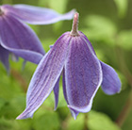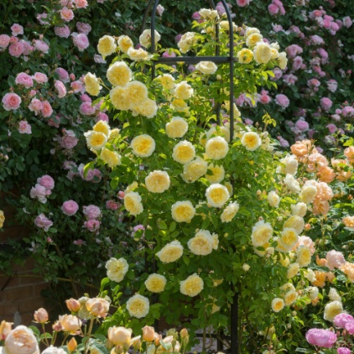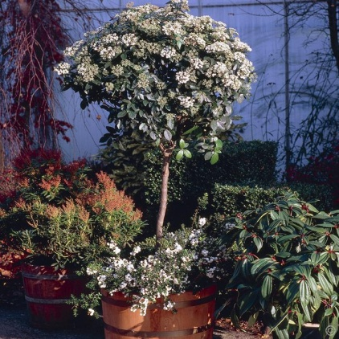
Cl. alpina (Apr - May) Rosa 'The Pilgrim Standard viburnum tinus (E)

A planting of the shorter grandiflorum delphiniums such as 'Summer Nights' and 'Blue Mirror', salvia nemorosa 'Caradonna'mixed with the yellow ground cover rose 'Worcestershire', yellow santolina and lavender. Daphne, a small evergreen shrub with white flowers which last from April through to October, to be placed close to the dining table to enjoy its fabulous scent. A planting of mixed spring-flowering bulbs would prolong the period of interest
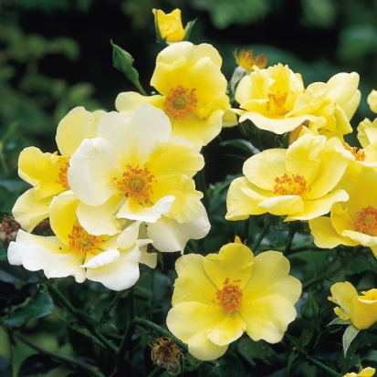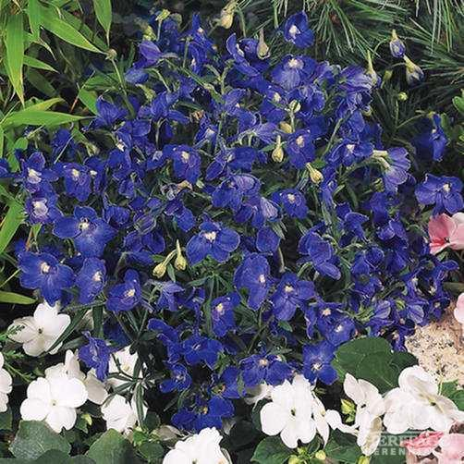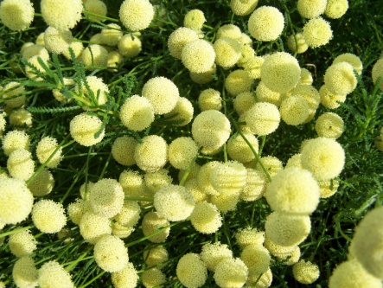
R 'Worcestershire' (2' x 3') Delph. 'Summer Nights' Santolina 'Primrose Gem' (E)

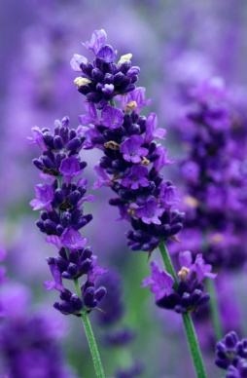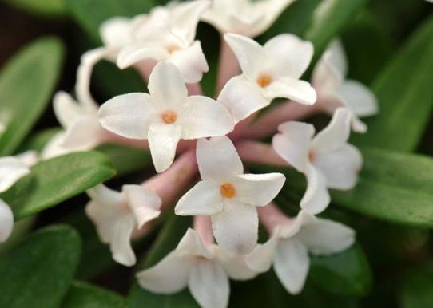
Lav. 'Imperial Gem' Daphne 'Eternal Fragrance' (E)

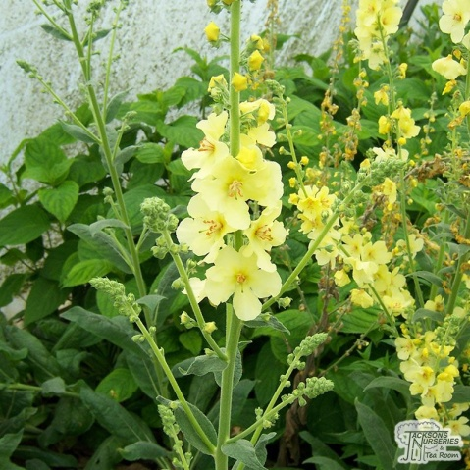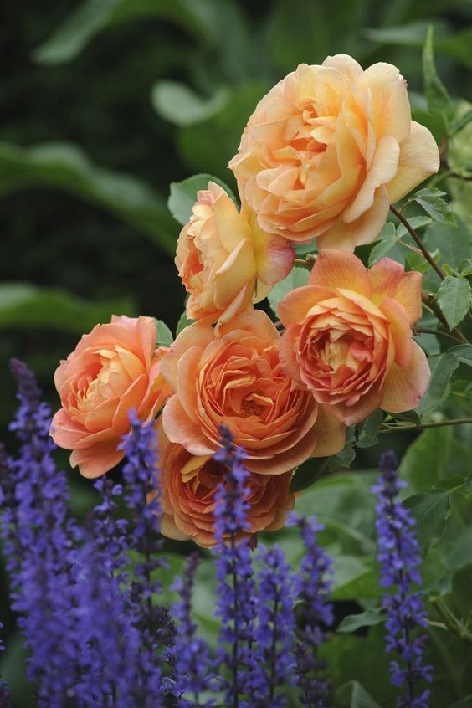
Verbascum 'Gainsborough' R. 'Emma Hamilton' & salvia

On the other side of the dining terrace a rose arch supported a clematis that had become rather woody and was too large for the support in any event. It was replaced with a smaller honeysuckle to fill the terrace with scent..

Long border
This border is shadier owing to its orientation and the conifer hedge and house restrict sunlight to some degree along part of the planting area. It is advisable therefore to use plants & varieties which are tolerant of some shade. Some large existing shrubs were retained including spotted laurel, pyracantha, mahonia & spiraea. Viburnum plicatum 'Mariesii' was planted along with the beautiful shrub exochorda macrantha 'The Bride'. Some short white repeat-flowering rambling roses, 'Snowgoose, ' were planted along the fence with white & blue clematis, and a yellow winter-flowering jasmine.

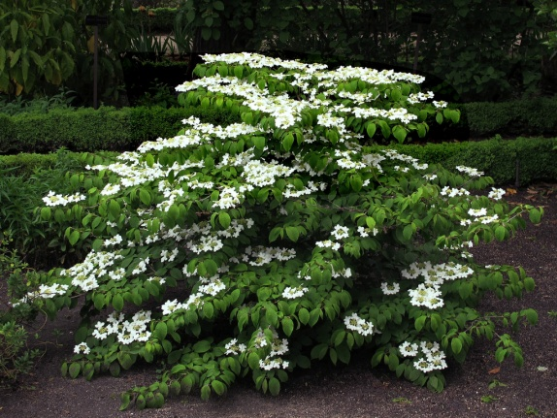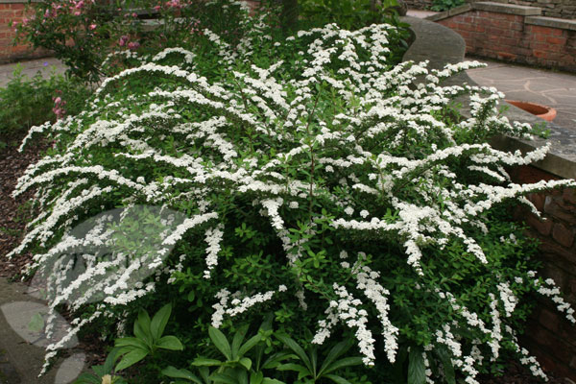
Viburnum plicatum 'Mariesii' Spiraea nipponica

Unfortunately in terms of the colour scheme, whilst it is tempting to imagine blue hydrangeas, in practical terms the alkaline soil would result in pink flowers. The solution was to use the white or cream forms. Hydrangea 'Annabelle' has huge white flower heads and was repeated in the border. A selection of blue and white geraniums, with low evergreen shrubs are planted at the front of the border with taller perennnials behind - in the sunny areas stately blue and white delphiniums, yellow and cream lupins, and in shadier areas some soft peach and creamy yellow foxgloves. Digitalis grandiflora and the Dalmatian strain are lower growing variants of the common foxglove and generally don't need staking making for easier maintenance.

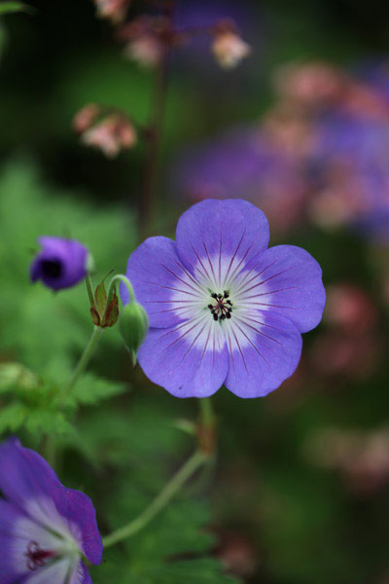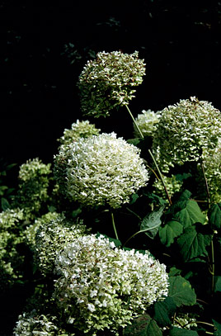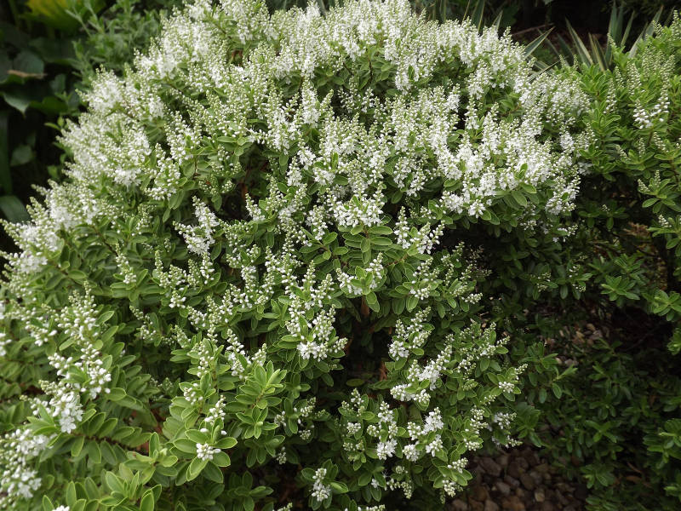
G. 'Rozanne' Hydrangea 'Annabelle' Hebe rakaiensis (E)

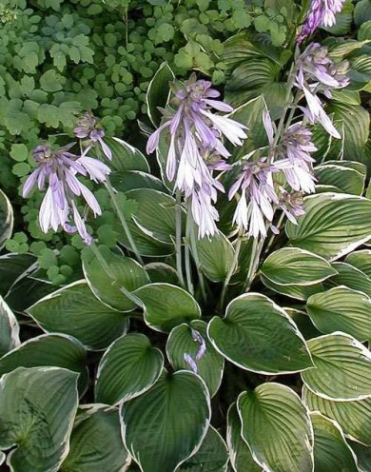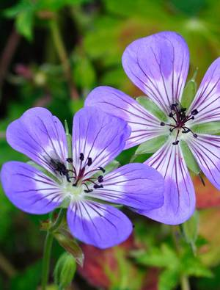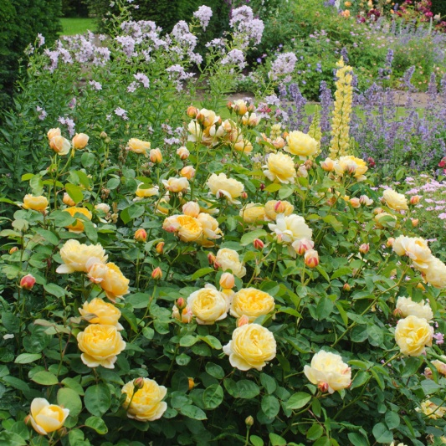
Hosta 'Francee' Geranium 'Buxton's Variety' Rosa 'Charlotte'

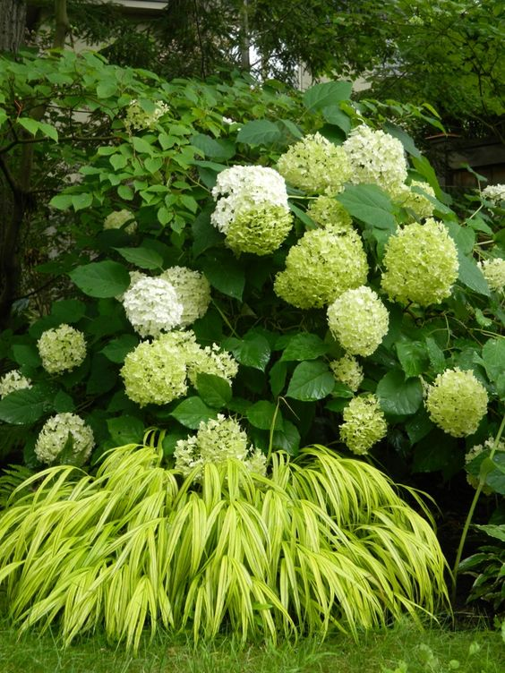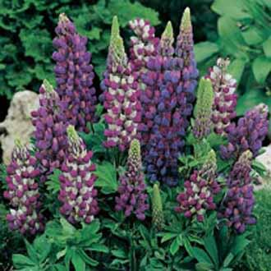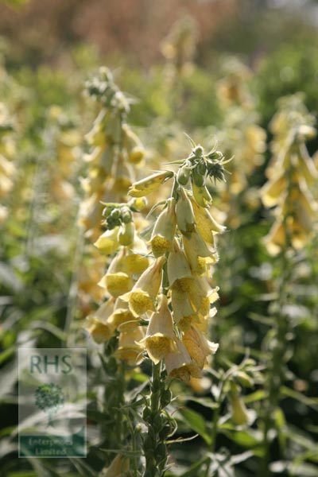
Lupinus 'Gallery Blues' Lupinus 'Gallery Blue' Digitalis grandiflora

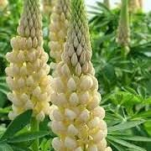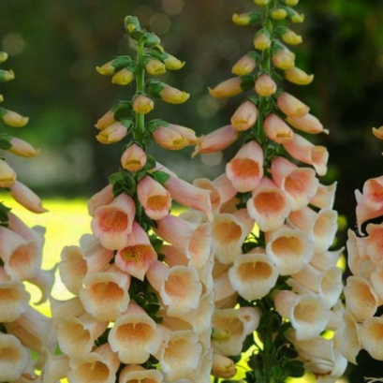
Lupinus 'Cashmere Cream' 'Digitalis 'Dalmatian Peach'

Planting bed 2
A peony, asters, irises and crocosmias were retained although the crocosmias were thinned out. The back of this border is in shade so liriope, which thrives in even the shadiest spot, provides texture and colour. Skimmia confusa 'Kew Green' is an unusual dome-shaped evergreen shrub that thrives in clay soils and requires little or no routine maintenance. Shade tolerant blue geraniums were included, repeating their.
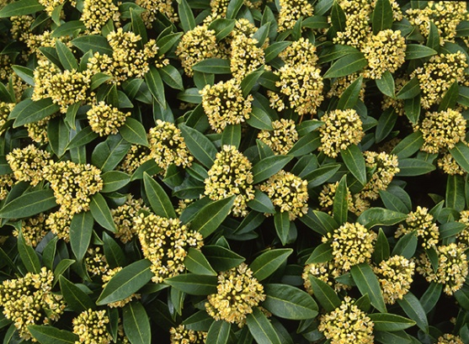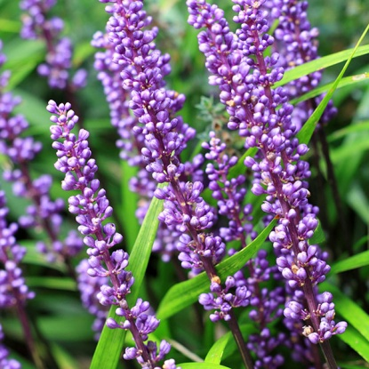
Skimmia x confusa 'Kew Green' (E) Liriope 'Big Blue' (E)
The garden owner loves paeonies so more maybe planted next year. They generally require full sun or partial shade but like heavier soils, conditions which can be met in this garden.
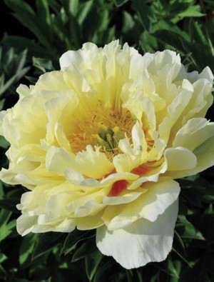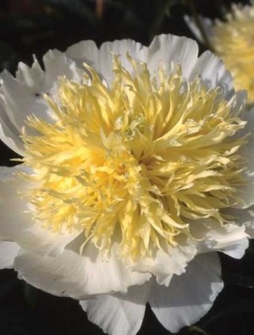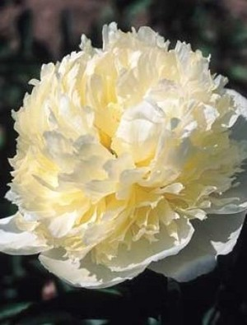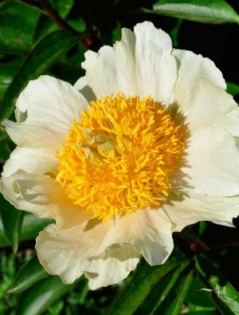
P. 'Bartzella' P. 'Honey Gold' P. 'Laura Dessert' P. 'Claire de Lune'
(Mid-season) (early, scented) (mid-season, scented) (early, scented)
Corner bed
This sunny corner bed was already planted with established buddleia, lilac and ceanothus for structure and then add perennials to provide colour. The rest of the border was cleared. It is now edged with lavender and will be planted with delphiniums, lupins, achilleas, geums & verbascum such as 'Gainsborough'.
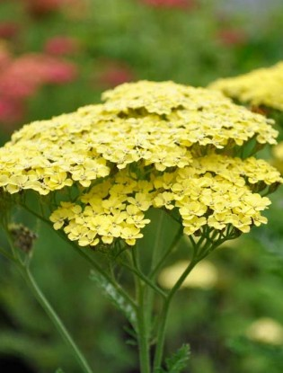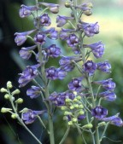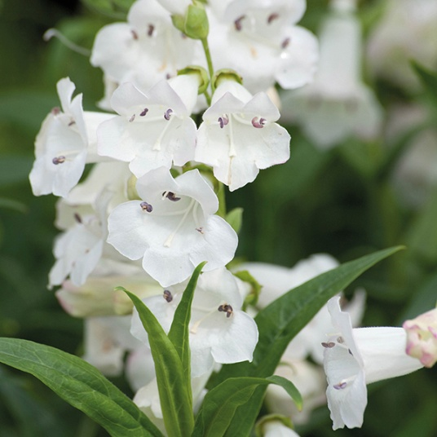
Achillea 'Credo Delphinium exaltatum Penstemon 'Snowstorm'
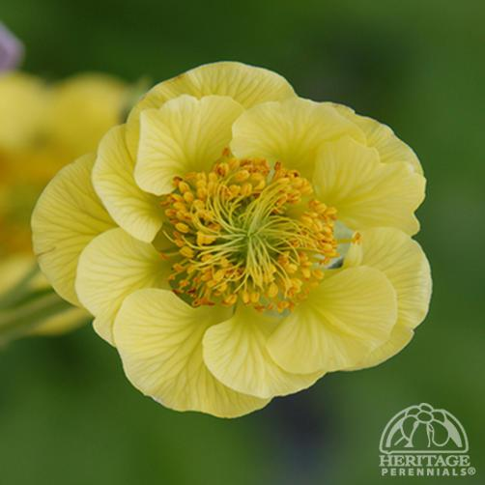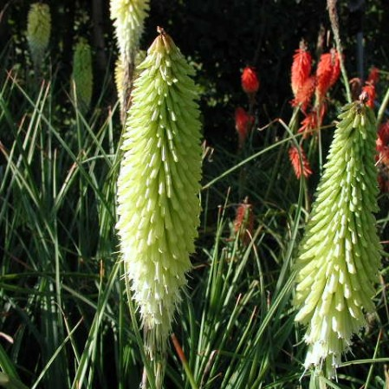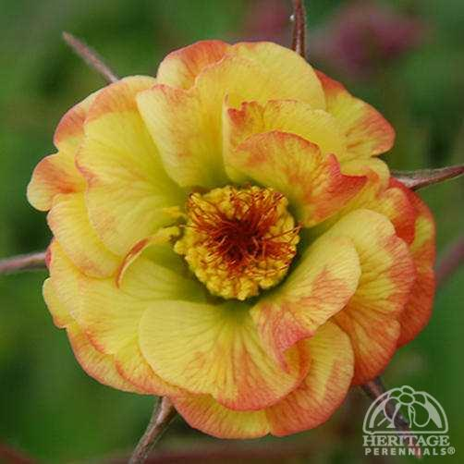
Geum 'Banana Daiquiri Kniphofia 'Percy's Pride' Geum 'Tequila Sunrise'
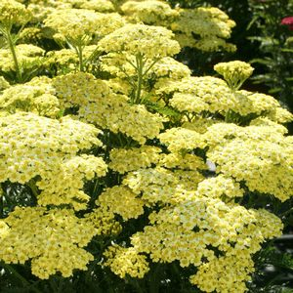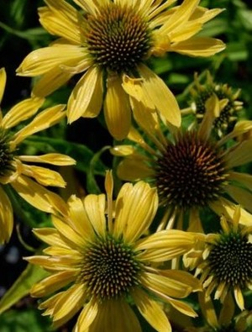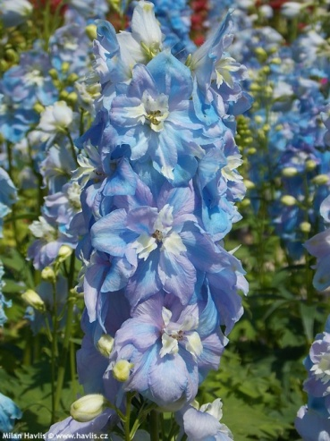
Achillea 'Sunny Seduction' Echinacea 'Sunrise' D. 'Excal. Light Blue'
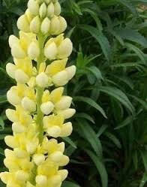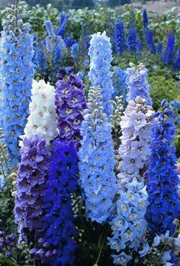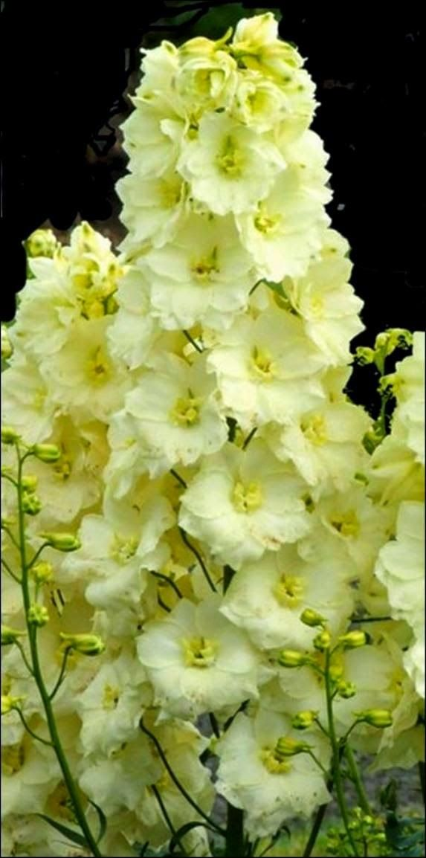
Lupinus 'Chandelier' Delphiniums Delphinium 'Sungleam'

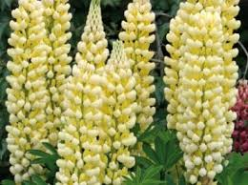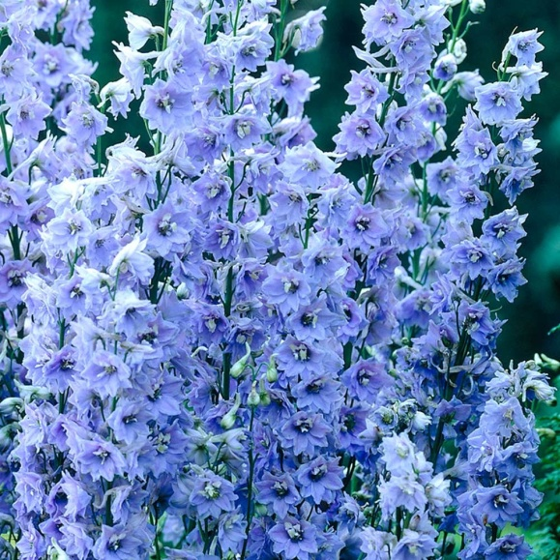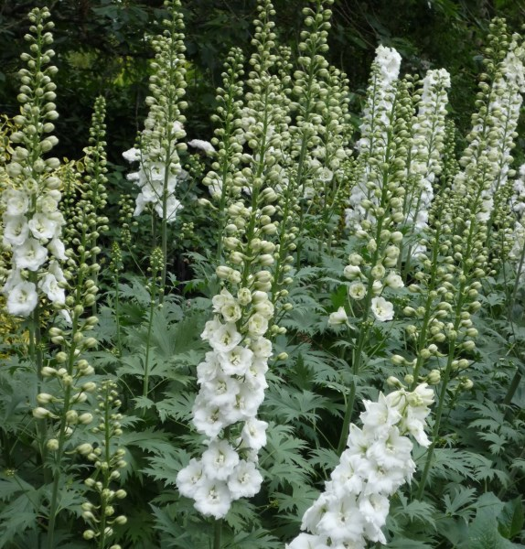
Lupin 'Gallery Yellow' Delphinium 'Summer Skies' Delphinium 'Galahad'

